

**Semester -1 Physics Project**

**Done by :**

DIVITH PHOGAT – AIEA.14193

GARAPATI VENKATA KRISHNA – AIEB.24735

JAYANTH M – AIEB.10655

KARNATI SAI PRASHANTH – AIEB.25264

MANISH RAMA GOPAL NADELLA - AIEB.12015

**Concept**:

DISTRIBUTED LOADING

In many situations a surface area of a body is subjected to a distributed load. Such forces are caused by winds, fluids, or the weight of items on the body’s surface. We will analyse the most common case of a distributed pressure loading. This is a uniform load along one axis of a flat rectangular body. In such cases, w is a function of x and has units of force per length.

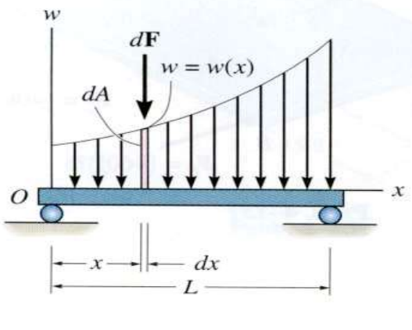 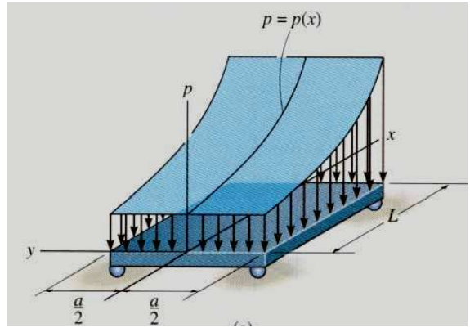

MAGNITUDE OF RESULTANT FORCE

Consider an element of length dx. The force magnitude dF acting on it is given as

dF = w(x) dx

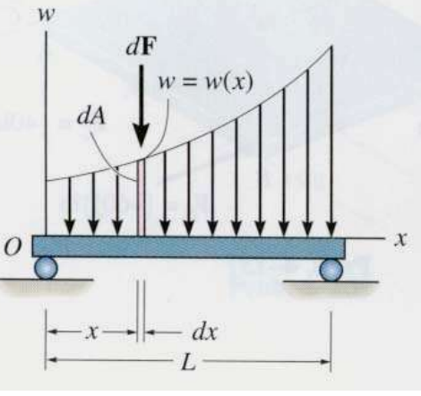

The net force on the beam is given by

+ ¯ FR = òL dF = òL w(x) dx = A

Here A is the area under the loading curve w(x).

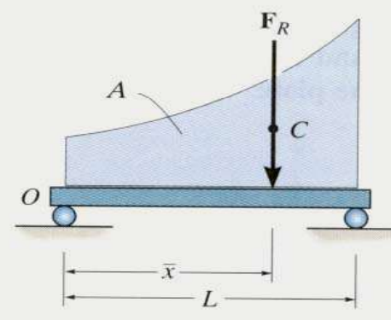

LOCATION OF THE RESULTANT FORCE

The force dF will produce a moment of (x)(dF) about point O. The total moment about point O is given as + MRO = òL x dF = òL x w(x) dx Assuming that FR acts at 𝑥 , it will produce the moment about point O as + MRO = (𝑥 ) (FR ) = 𝑥 òL w(x) dx

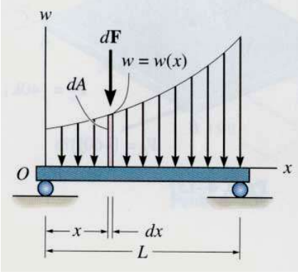 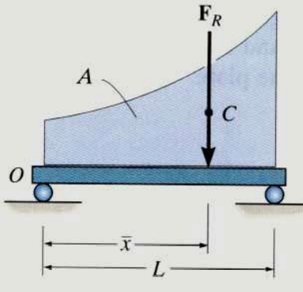

Comparing the last two equations,

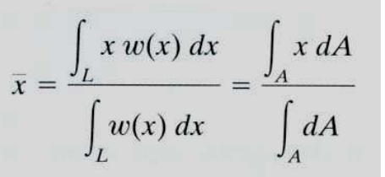

we get to learn later that FR acts through a point “C,” which is called the geometric centre or centroid of the area under the loading curve w(x).

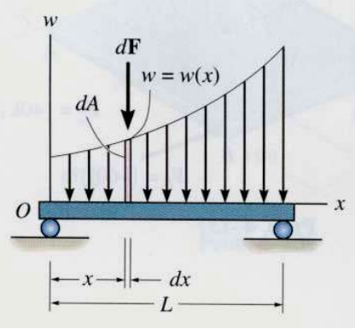 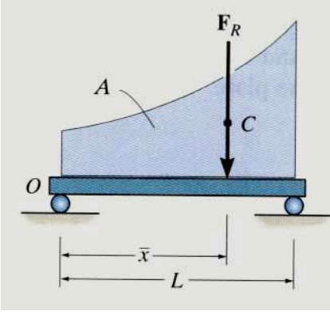

**Given question**:

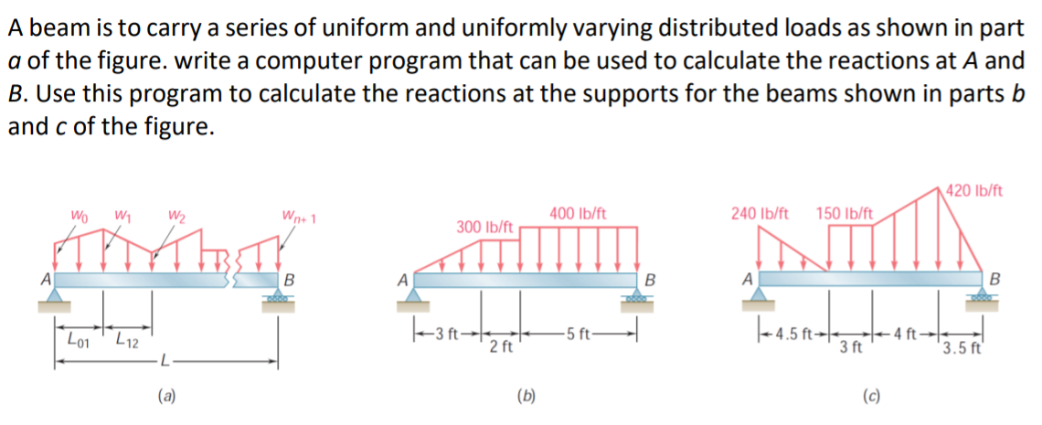

**Solution**:

**Solving without program:**

**Solution for (b):**

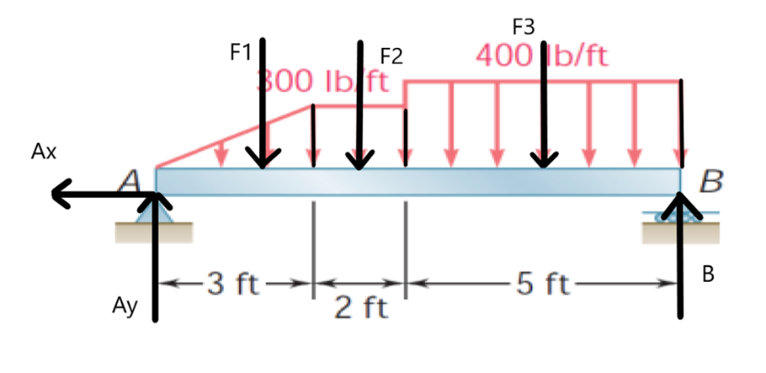

Free body diagram

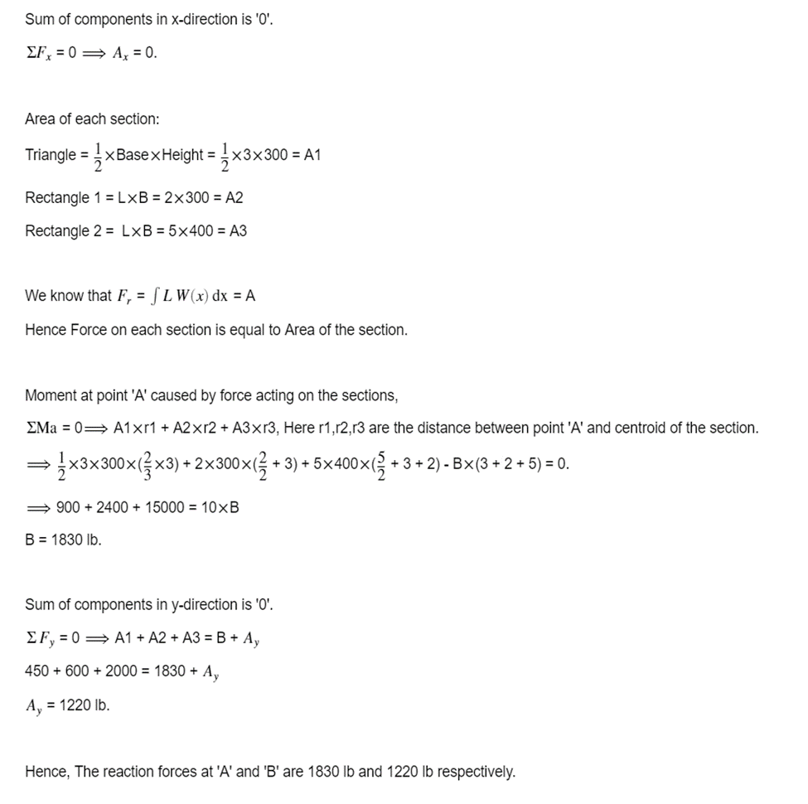

**Solution for (c):**

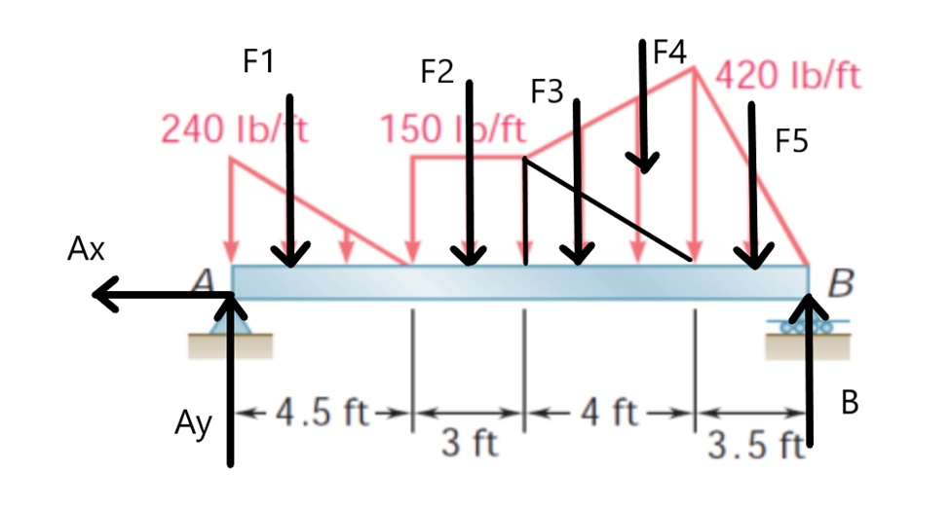

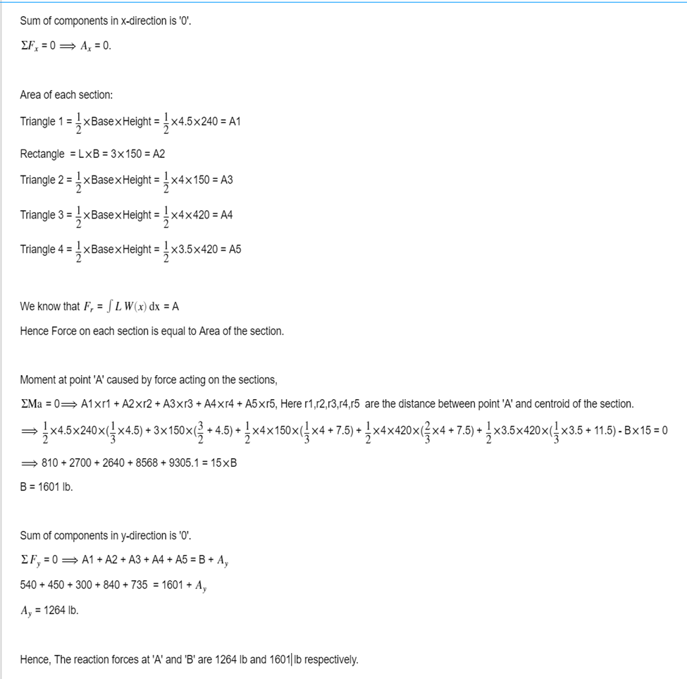

**MATLAB code:**

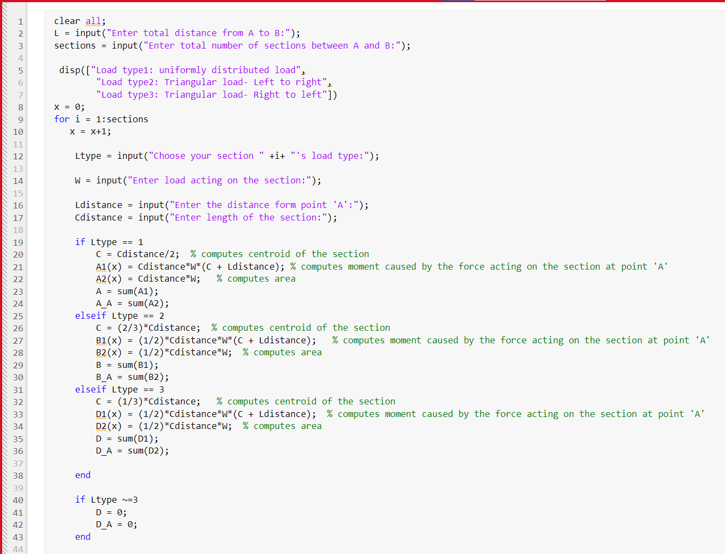

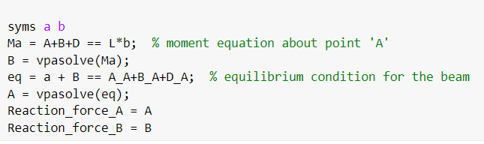

**Solution for (b) using the above code:**

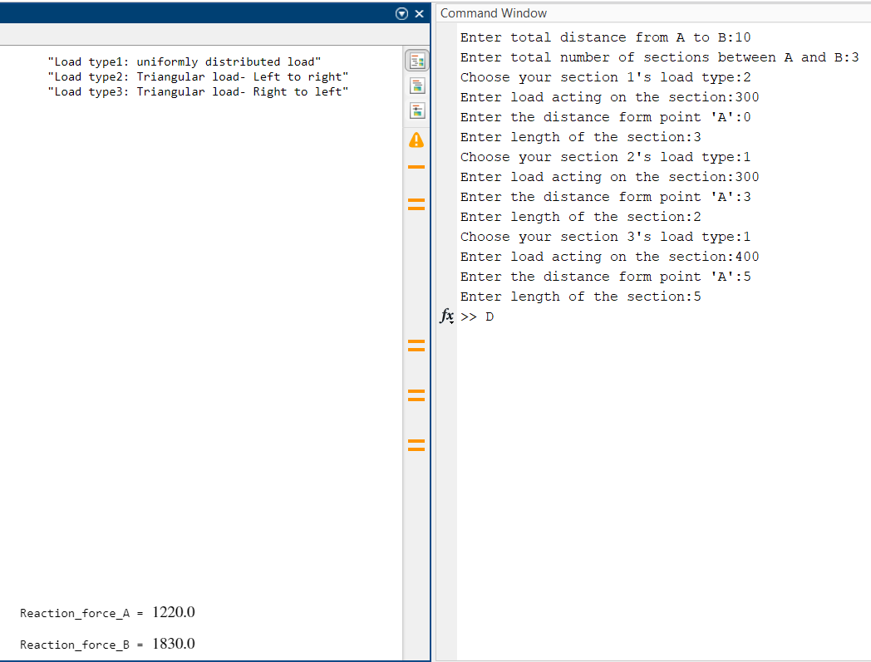

**Solution for (c) using the above code:**

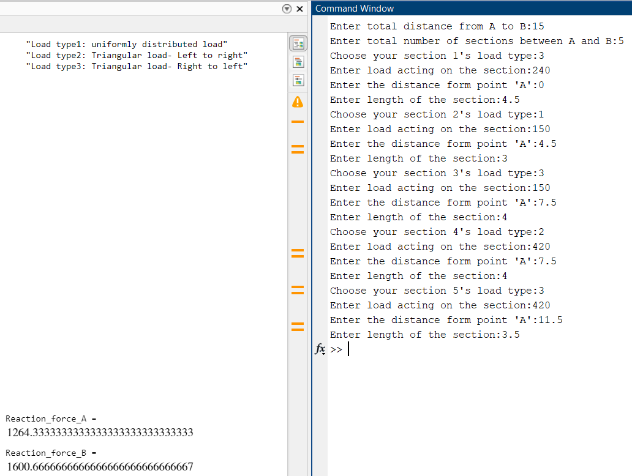

**Code in C language**:

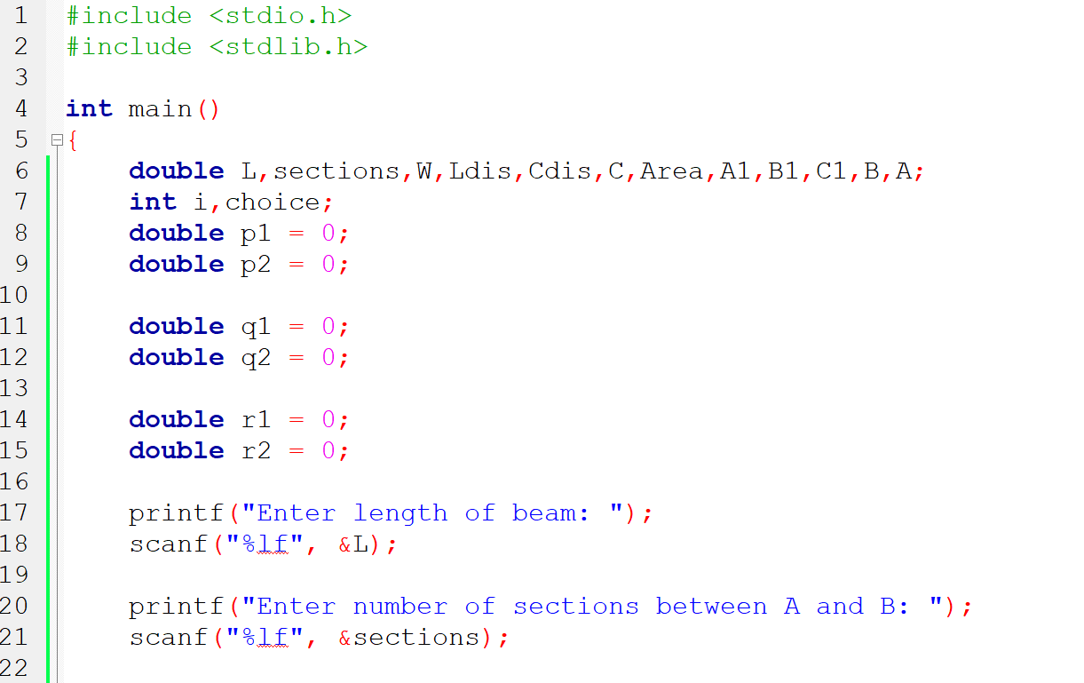

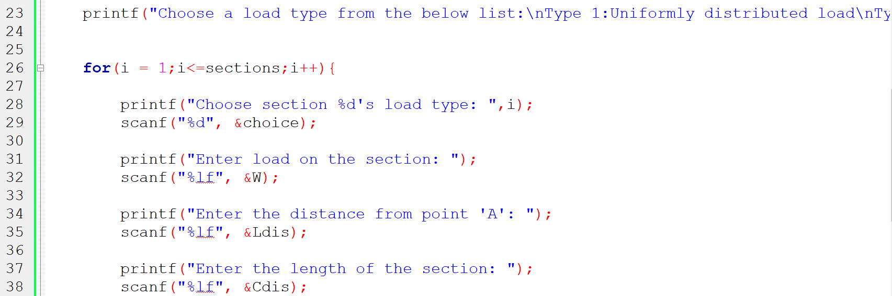

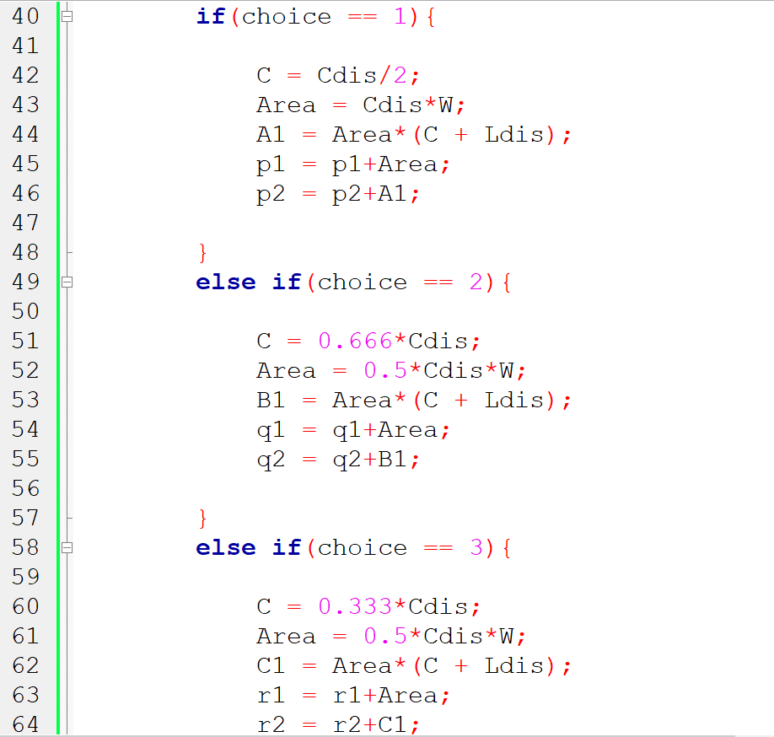

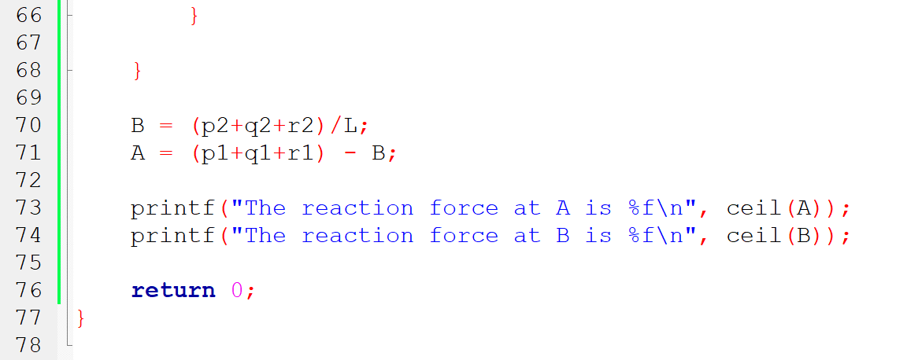

**Solution for (b) using the above code:**

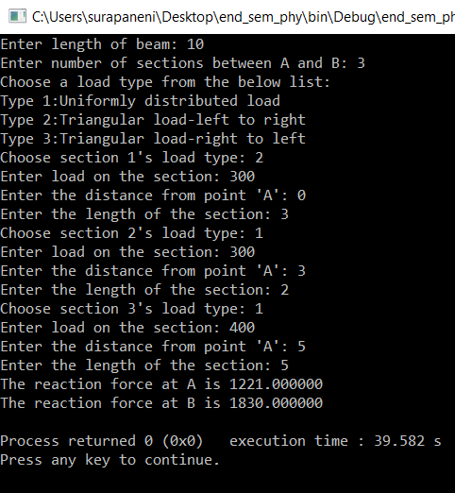

**Solution for (c) using the above code:**

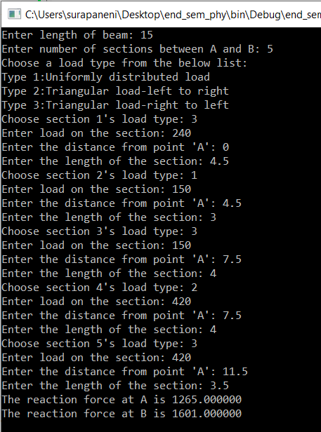

**JAVA code:**

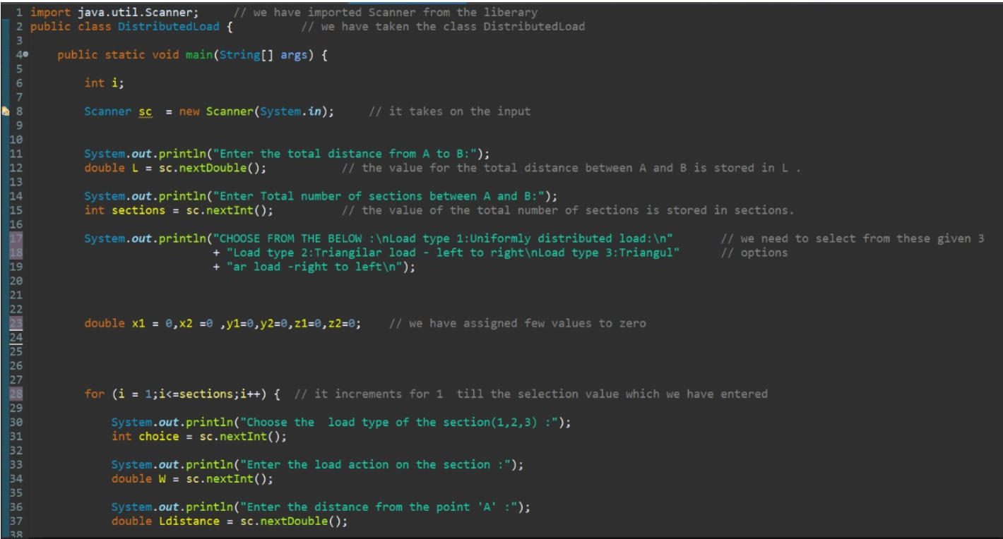

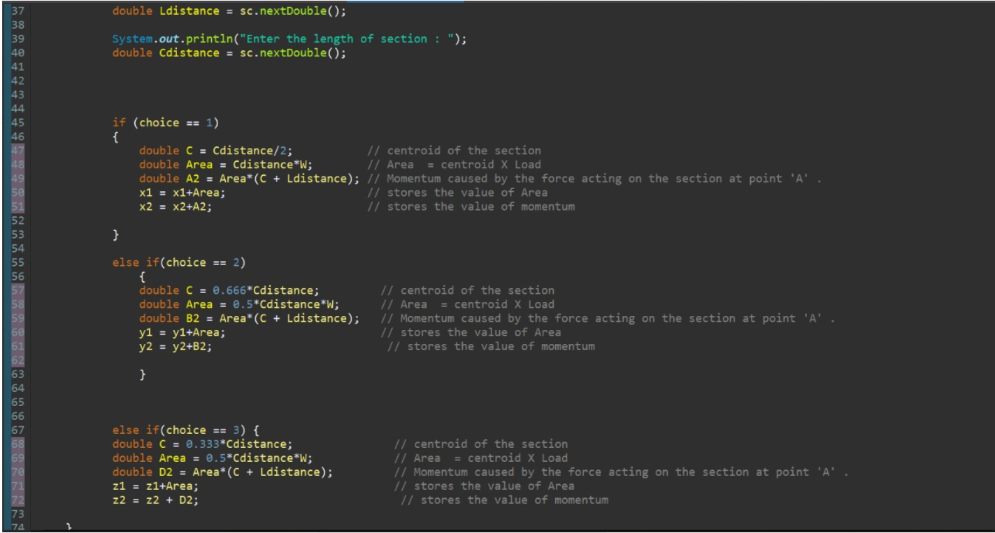

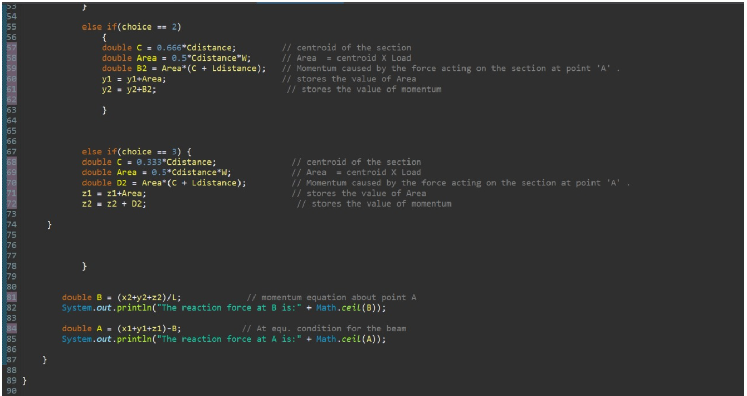

**Solution for (b) using the above code:**

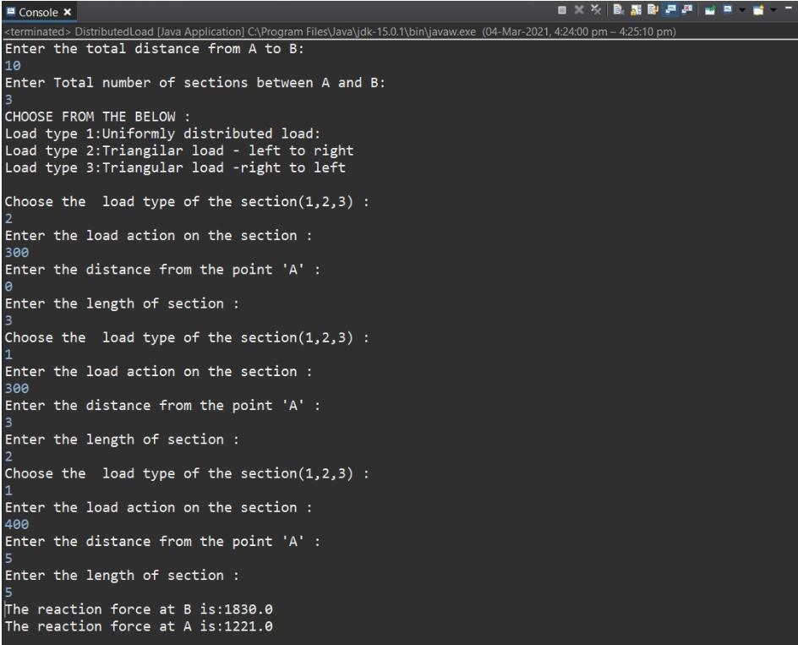

**Solution for (c) using the above code:**

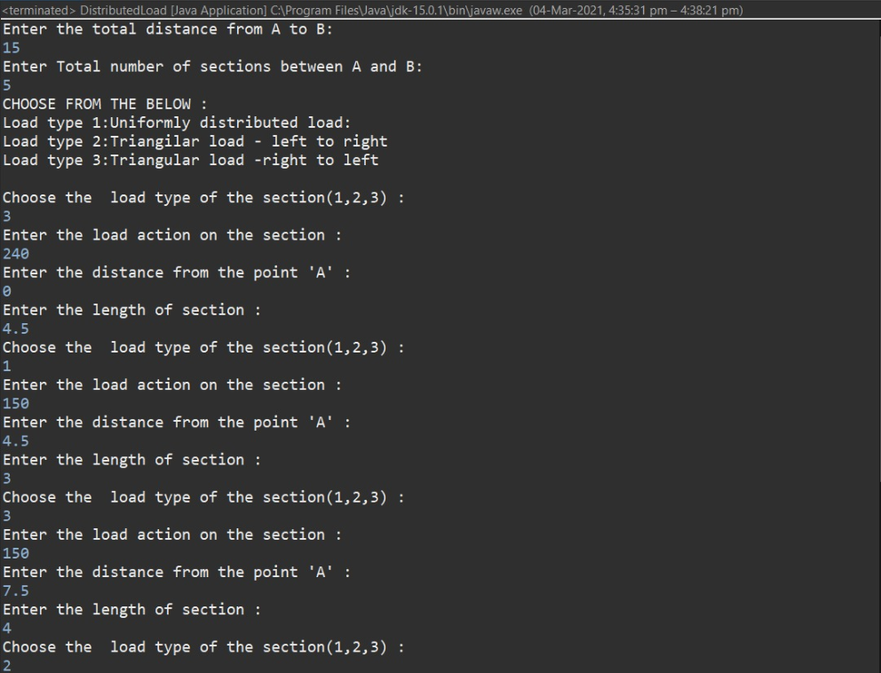

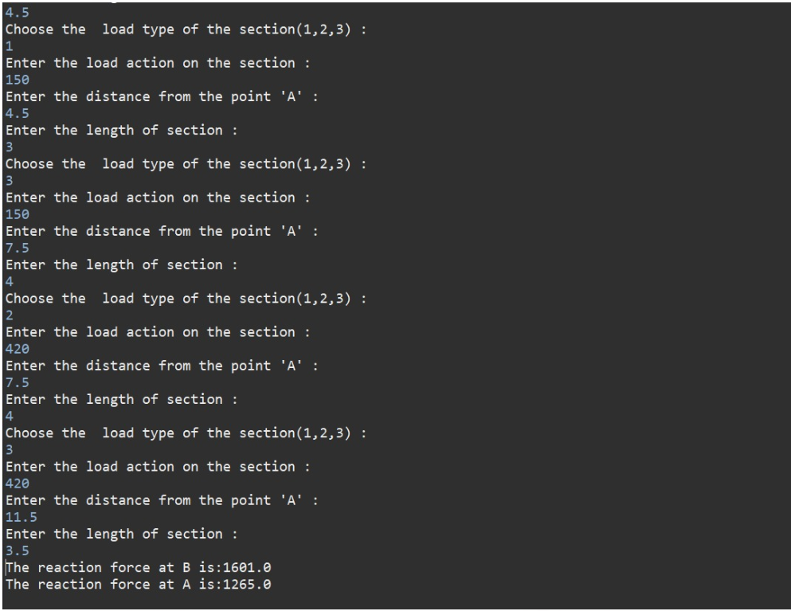

**PYTHON code:**